Bug Report Document

**Pakistan post**

HAFIZ HASEEB AKRAM

2024

**Bugs Summary:**

BUG REPORT DOCUMENT

|  |  |
| --- | --- |
| About section | **3** |
| Post Code | **2** |
| Stamps | **1** |
| Contact Us | **1** |
| Track and Trace | **6** |
| Total Bugs | **13** |

# Bug ID: 001

**Title:** Contact Form.

**Description:** When a user clicks on the About page, there must be a contact us form available for user.

## Steps to Reproduce:

1. Open the Pakistan Post Website(https://www.pakpost.gov.pk/).
2. Click on About page.

**Expected Result:** Form submits successfully with confirmation message.

**Actual Result:** The user is not getting any form.  
 Severity: Medium

Priority: Medium

## Environment:

**Browser**: Google Chrome, Firefox, Edge   
**Operating System**: Window, Android   
**Device:** Desktop, Mobile,

**Network:** Wi-Fi, 4G

## Attachments:



# Bug ID: 002

**Title:** User Feedback.

**Description:** User Feedback option must be available in about page of the Pakistan Post Website.

## Steps to Reproduce:

1. Open the Pakistan Post Website(https://www.pakpost.gov.pk/).
2. Click on About page.

## Expected Result:

Feedback Should be submitted and acknowledged properly.

## Actual Result:

Feedback option Not Available.

**Severity**: Medium   
**Priority:** High   
**Environment:**

**Browser**: Google Chrome, Firefox, Edge   
**Operating System**: Window, Android   
**Device:** Desktop, Mobile,

**Network:** Wi-Fi, 4G

## Attachments:

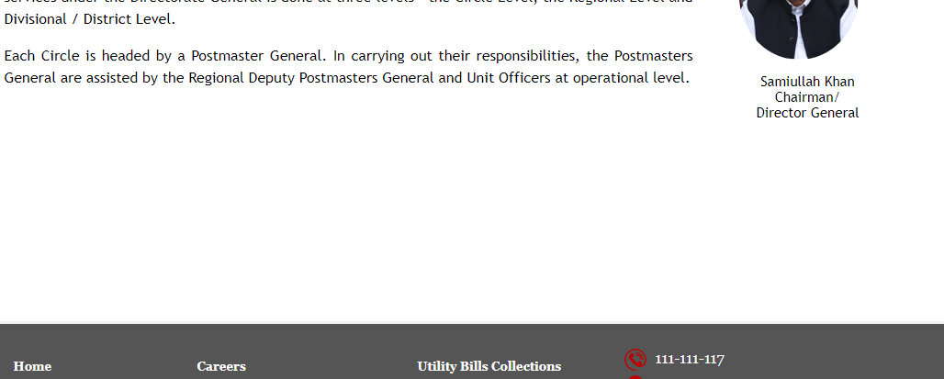

# Bug ID: 003

**Title**: Contact Details

**Description:** The about page must have Contact information which is correct and up-to-date related to Pakistan Post Website.

## Steps to Reproduce:

1. Open the Pakistan Post Website(https://www.pakpost.gov.pk/).
2. Click on About page.

**Expected Result:** Contact information Should be correct and up-to-date

**Actual Result:** Not Available.

**Severity**: Medium   
**Priority**: High   
**Environment:**

**Browser**: Google Chrome, Firefox, Edge   
**Operating System**: Window, Android   
**Device:** Desktop, Mobile,

**Network:** Wi-Fi, 4G

## Attachments:

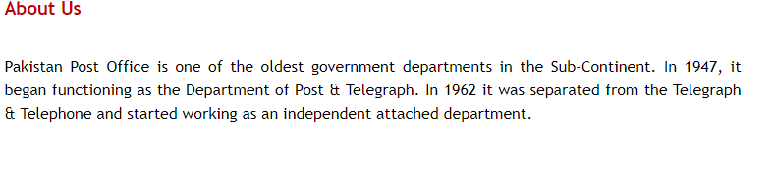

# Bug ID: 004

**Title**: Search History Availability

**Description**: The post code must have Search History in the Pakistan Post Website.

## Steps to Reproduce:

1. Open the Pakistan Post Website(https://www.pakpost.gov.pk/).
2. Click on Post Code page.

**Expected Result:** Search history Should be maintained and accessible.

**Actual Result:** No Search history

**Severity**: Medium   
**Priority**: High   
**Environment:**

**Browser**: Google Chrome, Firefox, Edge  
 **Operating System**: Window, Android   
**Device:** Desktop, Mobile,

**Network:** Wi-Fi, 4G

## Attachments:

## 

# Bug ID: 005

**Title**: Export File.

**Description**: The must be download or export option available for post code file in the Pakistan Post Website.

## Steps to Reproduce:

1. Open the Pakistan Post Website(https://www.pakpost.gov.pk/).
2. Click on Post Code page.

**Expected Result:** Exported option available and file contains accurate data.   
**Actual Result:** Not available.   
**Severity**: Major

**Priority**: High

## Environment:

**Browser**: Google Chrome, Firefox, Edge

**Operating System**: Window, Android

**Device:** Desktop, Mobile,

**Network:** Wi-Fi, 4G

## Attachments:

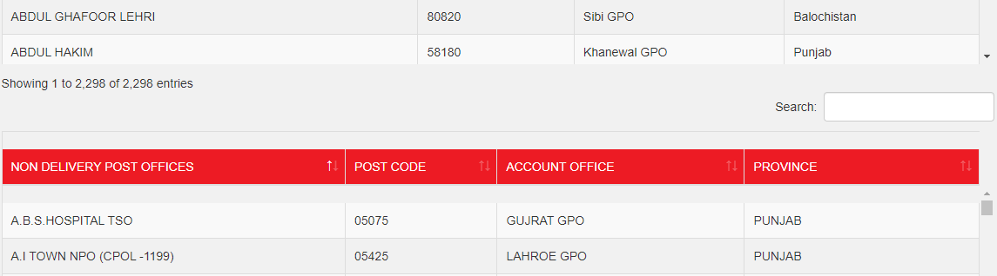

# Bug ID: 006

**Title**: Stamp Ordering Online.

**Description:** The Stamp Page must have online ordering system to online order a stamp in the Pakistan Post Website.

## Steps to Reproduce:

1. Open the Pakistan Post Website(https://www.pakpost.gov.pk/).
2. Click on Stamps page.

**Expected Result:** Order process Should be straight forward and user-friendly.   
**Actual Result:** Not Available.  
 **Severity**: High

**Priority**: Medium

## Environment:

**Browser**: Google Chrome, Firefox, Edge

**Operating System**: Window, Android

**Device:** Desktop, Mobile,  
**Network:** Wi-Fi, 4G **Attachments:**

## 

# Bug ID: 007

**Title**: Clickable Emails

**Description**: Contact us page must have proper contact information which is correct and clickable in the Pakistan Post Website.

## Steps to Reproduce:

1. Open the Pakistan Post Website(https://www.pakpost.gov.pk/).
2. Click on Contact Us page.

**Expected Result**: Clicking email should open default email.   
**Actual Result**: Not Clickable.   
**Severity**: High

**Priority**: Critical

## Environment:

**Browser**: Google Chrome, Firefox, Edge   
**Operating System**: Window, Android   
**Device:** Desktop, Mobile,

**Network:** Wi-Fi, 4G

## Attachments:

## 

# Bug ID: 008

**Title**: Tracking Number with Spaces

**Description**: In Track and Trace page we track our parcel typing different types of input to check our Track result in the Pakistan post Website.

## Steps to Reproduce:

1. Open the Pakistan Post Website(https://www.pakpost.gov.pk/).
2. Click on Track and Trace page.
3. Type tracking no in search bar.
4. Click Track button.

**Expected Result**: An error message Should be displayed indicating the tracking number Should be invalid.   
**Actual Result**: Provide empty result.   
**Severity**: Medium

**Priority**: High

## Environment:

**Browser**: Google Chrome, Firefox, Edge   
**Operating System**: Window, Android   
**Device:** Desktop, Mobile,

**Network:** Wi-Fi, 4G

## Attachments:

## 

# Bug ID: 009

**Title**: Tracking Number with Letters Only.

**Description**: In Track and Trace page we track our parcel typing different types of input to check our Track result in the Pakistan post Website.

## Steps to Reproduce:

1. Open the Pakistan Post Website(https://www.pakpost.gov.pk/).
2. Click on Track and Trace page.
3. Type tracking no in search bar.
4. Click Track button.

**Expected Result**: An error message Should be displayed indicating the tracking number Should be invalid.   
**Actual Result**: Provide empty result.   
**Severity**: Medium

**Priority**: High

## Environment:

**Browser**: Google Chrome, Firefox, Edge   
**Operating System**: Window, Android   
**Device:** Desktop, Mobile,

**Network:** Wi-Fi, 4G

## Attachments:

## 

# Bug ID: 010

**Title**: Tracking Number with Special Characters and Letters

**Description**: In Track and Trace page we track our parcel typing different types of input to check our Track result in the Pakistan post Website.

## Steps to Reproduce:

1. Open the Pakistan Post Website(https://www.pakpost.gov.pk/).
2. Click on Track and Trace page.
3. Type tracking no in search bar.
4. Click Track button.

**Expected Result**: An error message Should be displayed indicating the tracking number Should be invalid.   
**Actual Result**: Provide empty result.   
**Severity**: Medium

**Priority**: High

## Environment:

**Browser**: Google Chrome, Firefox, Edge   
**Operating System**: Window, Android   
**Device:** Desktop, Mobile,

**Network:** Wi-Fi, 4G

## Attachments:

## 

# Bug ID: 011

**Title**: Tracking Number with HTML Tags

**Description**: In Track and Trace page we track our parcel typing different types of input to check our Track result in the Pakistan post Website.

## Steps to Reproduce:

1. Open the Pakistan Post Website(https://www.pakpost.gov.pk/).
2. Click on Track and Trace page.
3. Type tracking no in search bar.
4. Click Track button.

**Expected Result**: An error message Should be displayed indicating the tracking number Should be invalid.   
**Actual Result**: Provide empty result.   
**Severity**: Medium

**Priority**: High

## Environment:

**Browser**: Google Chrome, Firefox, Edge   
**Operating System**: Window, Android   
**Device:** Desktop, Mobile,

**Network:** Wi-Fi, 4G

## Attachments:

## 

# Bug ID: 012

**Title**: Tracking Number with Leading and Trailing Spaces

**Description**: In Track and Trace page we track our parcel typing different types of input to check our Track result in the Pakistan post Website.

## Steps to Reproduce:

1. Open the Pakistan Post Website(https://www.pakpost.gov.pk/).
2. Click on Track and Trace page.
3. Type tracking no in search bar.
4. Click Track button.

**Expected Result**: An error message Should be displayed indicating the tracking number Should be invalid.   
**Actual Result**: Provide empty result.   
**Severity**: Medium

**Priority**: High

## Environment:

**Browser**: Google Chrome, Firefox, Edge   
**Operating System**: Window, Android   
**Device:** Desktop, Mobile,

**Network:** Wi-Fi, 4G

## Attachments:

## 

# Bug ID: 013

**Title**: Tracking Number with Mathematical Operators

**Description**: In Track and Trace page we track our parcel typing different types of input to check our Track result in the Pakistan post Website.

## Steps to Reproduce:

1. Open the Pakistan Post Website(https://www.pakpost.gov.pk/).
2. Click on Track and Trace page.
3. Type tracking no in search bar.
4. Click Track button.

**Expected Result**: An error message Should be displayed indicating the tracking number Should be invalid.   
**Actual Result**: Provide empty result.   
**Severity**: Medium

**Priority**: High

## Environment:

**Browser**: Google Chrome, Firefox, Edge   
**Operating System**: Window, Android   
**Device:** Desktop, Mobile,

**Network:** Wi-Fi, 4G

## Attachments:

## 

## Conclusion of Bug Report: Pakistan Post Website

This bug report identifies several key issues with the Pakistan Post website that need immediate attention:

1. **Functional Problems**: Key features like Post Code Lookup and Contact Us are not working properly.
2. **User Experience**: The site is hard to navigate, and design elements are not user-friendly or responsive across devices.
3. **Security Risks**: There are vulnerabilities that could expose user data to risks.
4. **Performance**: The website is slow and inconsistent under different conditions.
5. **Compliance and Accuracy**: Content inaccuracies and regulatory compliance issues need correction.
6. **Feedback and Support**: The current feedback and support mechanisms are inadequate.